Unique Number:

Student Number: 64482790  
Student Name: Sashin Smith

ICT1513

Exam

Table of Contents

# Declaration Form

**ICT1513**

**INTRODUCTION TO WEB DESIGN**

I ____________Sashin Smith___________(name and surname) __9809175185086__________ (ID number), ___64482790__________ (Student number) hereby solemnly give my word that:

* The project I am submitting today is my own work.
* I have not received an unacceptable level of assistance in the preparation of the project.
* The project or any parts thereof do not correspond exactly with those of other learners or published/unpublished websites developed by a person other than myself.

Should it be found that the statement you have made here were not truthful you will receive 0 (zero) for you project and disciplinary action will be taken against you.

Signed ______________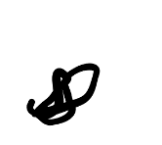___________________ on the ___04______ th day of

______June________ 2020 at _______4 Barrow street Monte Vista___________ (place).

# Project Proposal

Site title: Snip and Cut Beauty Salon

Development Roles: Sashin Smith to develop the entire website.

Need: The owners of Snip and Cut Beauty Salon require a website to attract new customers. The website must be attractive and provide the viewers with location, special promotions, services and information on the hairdresser.

Rationale or focus: The focus for the website is to attract new customers and inform users about the promotions and location. The website will mainly focus on providing information to the user.

Main elements outline: The website will consist of 3 pages, the home page, create promotion page and sign-up for promotion page. The home page will have a calendar, images and a short description. The create promotion page will have mainly have a section where the manager can edit and add promotions as they see fit. The sign-up for promotion page will have a form where the user can sign up for the promotion.

Content: The website will consist of 3 web pages.

1. Home page

• Name and logo

• A short description of the business and location

• A calendar with all the promotions highlighted

• A button that will allow the manager to add a new promotion

• 5 images that rotate

2. Create promotion

• A page that allows the creating a promotion

• Allows editing and deleting of promotions

3. Sign-up for promotion

• Where users can sign up for promotions

4. Discipline Code

* Must include the code
* Must have scrolling between pages

Target audience: The website will mainly be for users both male and female to look for a hairdresser. It will also be for the manager who will create promotions.

Design considerations: The design needs to be adaptable to all device sizes. It needs to be organized logically and be easy to read. It needs to have businesses colours, red and black.

Limiting factors: The things that would limit my design would be time restrictions. The audience might be limited to the location. If the users are too far out to come to this particular hairdresser.

Development Schedule, milestones, and deliverables:

* Schedule
* Millstones

|  |  |
| --- | --- |
| Dates | Tasks |
| 30 May | Project Proposal |
| 31 May | Flow chart and wireframes |
| 1-4 June | HTML development: Improvements |
| 4 June | HTML development: New Tab and content Added |
| 5 June | CSS development: CSS improvements |
| 6-9 June | Documentation and testing completing |
| 9 June | Exam questions and project end |

* Deliverables:
  + 4 Professional pages that use the businesses colours
  + Consistent branding throughout the web site
  + Home page with calendar and button to add promotions
  + The sign-up page that allows entering of details
  + Discipline Page with the code in it

Mission statement: Develop a website that easy to understand and users can navigate easily as well as use on many different devices.

How will sites success in meeting its goals be measured: Create a more efficient way to view promotions and create them.

How will user satisfaction with the site be measured: I will use interviews with some users who test run my website to measure success. The interviews will include the following questions:

1. Is the website easy to navigate?
2. Can you read and understand the text on this website?
3. Do you know what the website is about?
4. Do you know how to sign-up for a promotion?
5. What could be improved?

Indicate technological issues that may influence the site's development or function: I am limited to the devices that I may test for the website. I do not have the latest ISO devices only an older iPad and iPhone. This will limit testing on ISO. I also do not have older Android devices to test on.

# Flowchart

## Filename

* Home page: scbeauty_homepage.html
* Create Promotion: scbeauty_crprom.html
* Sign-up for promotion: scbeauty_signprom.html
* Discipline Code: scbeauty_students.html
* Subpages: page1.html – page13.html

## Links Between Pages

The links between pages use a navigation system to go between the home page and sign-up for the promotion page. The button on the home page takes the user to a create promotion page where the manager can create a promotion and then back to the home page. The Discipline page links to all 13 subpages and each subpage is linked to the next and previous pages.

## Structure

The basic three-page website that makes use of a navigation bar that allows the easy use of changing between web pages. The second navigation between the 13 subpages allow easy reading of the entire code.

# Wireframes

## Home page

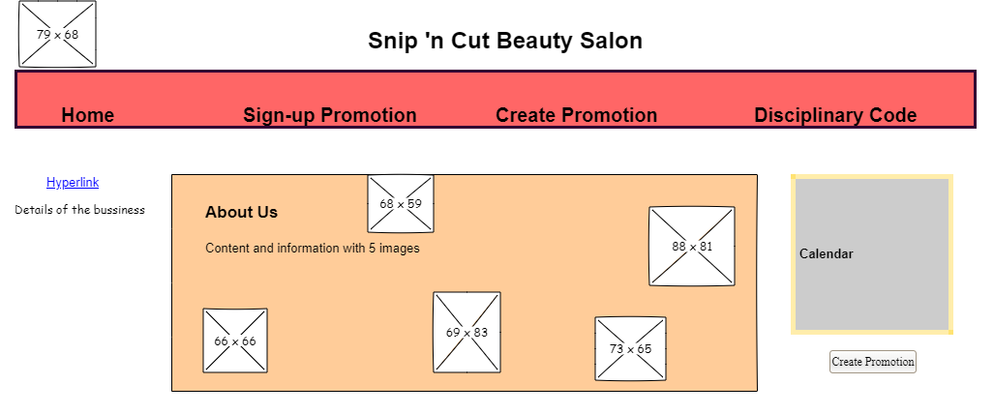

## Sign-up Promotion

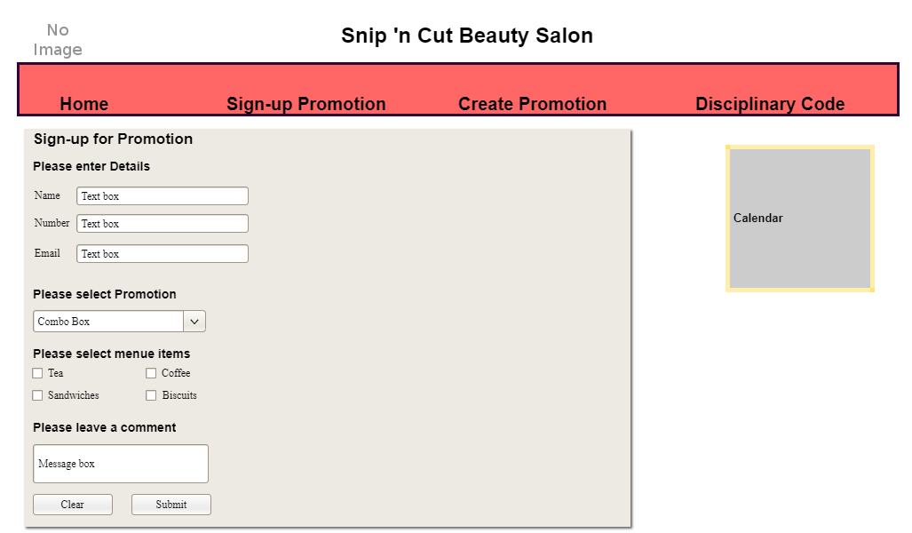

## Create Promotion

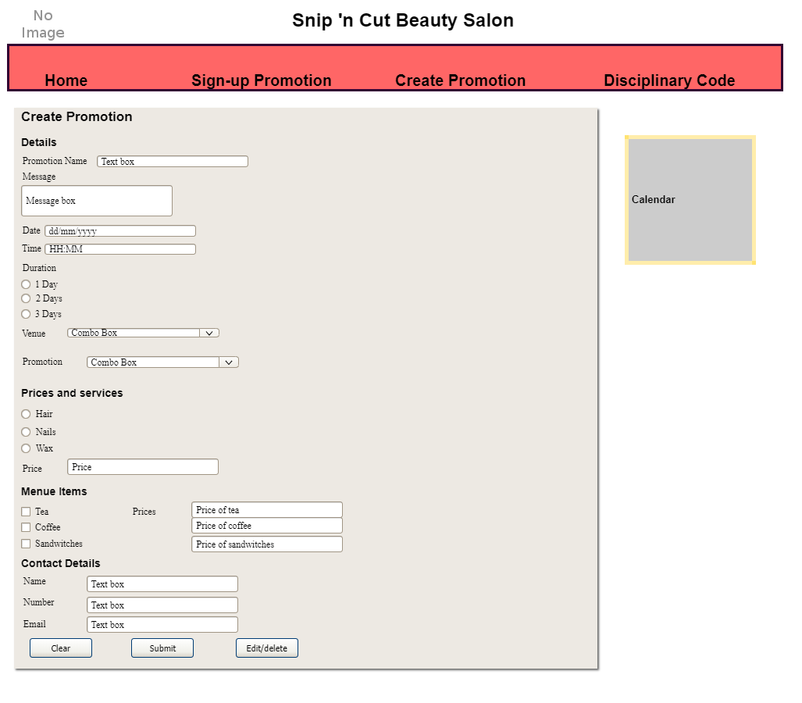

## Disciplinary Code

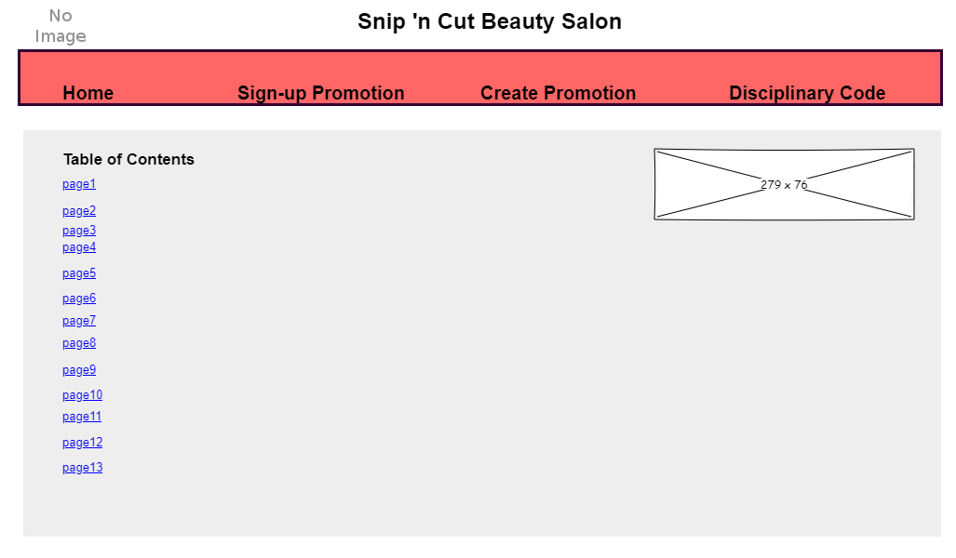

## Page 1

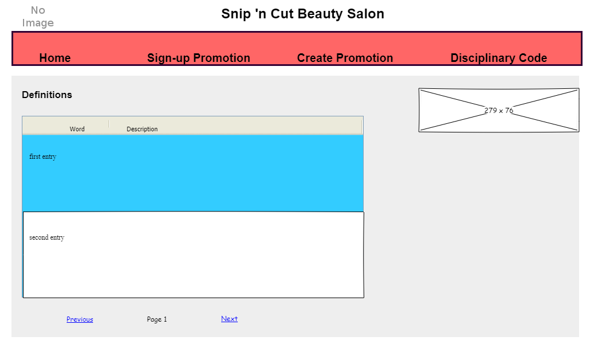

## Page 2

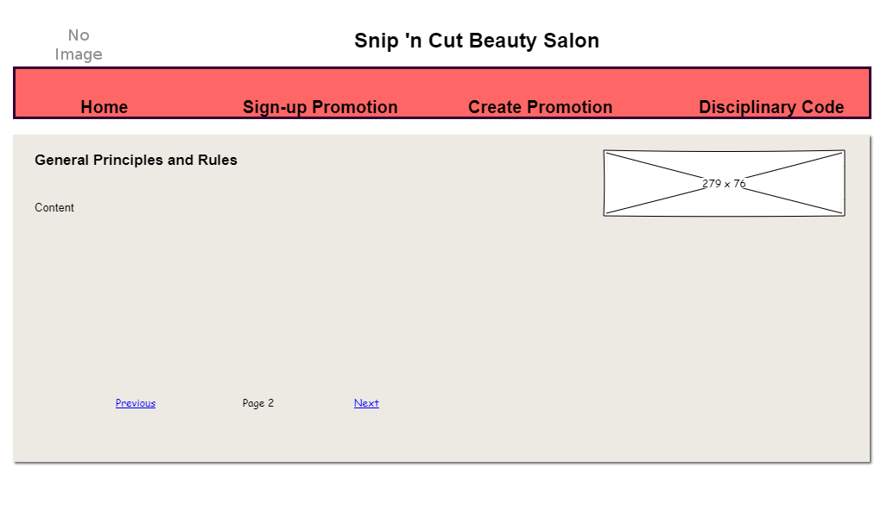

### Note:

I have made improvements to my wireframes since assignment 4. I made changes based on the comments, that included displaying all elements.

# HTML Code

## Home Page

<!DOCTYPE html>

<html>

<head>

<title>Snip 'n Cut Beauty Salon</title>

<meta http-equiv="Content-Type" content="text/html; charset=UTF-8">

<meta name="viewport" content="width=device-width, initial-scale=1.0">

<link href="styles.css" rel="stylesheet">

</head>

<body>

<div id="wrapper">

<header>

<img src="logo.png" width="100" height="80" class="logo" alt="logo.png">

<h1>Snip 'n Cut Beauty Salon</h1>

</header>

<nav>

<ul id="myNav">

<li class="current"><a href="scbeauty_homepage.html">Home</a></li>

<li><a href="scbeauty_signprom.html">Sign-up Promotion</a></li>

<li><a href="scbeauty_crprom.html">Create Promotion</a></li>

<li><a href="scbeauty_student.html">Disciplinary Code</a></li>

</ul>

</nav>

<section id="col3">

<nav>

<ul id="side">

<li><a href="https://www.google.com/maps/place/34-28+J+W+Theron+St,+Welgelegen+1,+Cape+Town,+7500/@-33.8783613,18.5639994,17z/data=!3m1!4b1!4m5!3m4!1s0x1dcc5bd3bdff2a77:0x196a7ec69f25072b!8m2!3d-33.8785832!4d18.5660042">Location</a></li>

<li>Contact number: 0219392983</li>

<li>Email: snipncut@gmail.com</li>

</ul>

</nav>

</section>

<section id="col1">

<article>

<h2>About Us </h2>

<h3>Who are we:</h3>

<p>

We are a team of 7 who make all your beauty dreams come true!

<img src="image1.jpg" width="250" height="200" class="imagesFormat" alt="image1.jpg">

</p>

<h3>Our aim:</h3>

<p>At Snip ‘n Cut Beauty Salon, we aim to provide exceptional service with a smile! We take pride in giving our customers the full pampering treatment of their choice</p>

<h3>The services we offer: </h3>

<p>

Hair:

<ul>

<li>Blow dry</li>

<li>Hair cut</li>

<li>Hair Highlights</li>

<li>Hair colour dye</li>

<li>Perms and curls</li>

</ul>

<img src="image2.jpg" width="230" height="200" class="imagesFormat" alt="">

Beauty:

<ul>

<li>Threading (upper lip, eyebrows and chin)</li>

<li>Waxing (bikini, armpits and face)</li>

</ul>

<img src="image3.jpg" width="230" height="200" class="imagesFormat" alt="">

</p>

<h3>Our prices</h3>

<p>

Hair:

<ul>

<li>Wash and cut: R170</li>

<li>Wash and blow dry: R130</li>

<li>Hair dye: from R139</li>

</ul>

<img src="image5.jpg" width="230" height="200" class="imagesFormat" alt="">

Beauty:

<ul>

<li>Threading of upper lip and eyebrows: R75</li>

<li>Threading on whole face: R100</li>

<li>Waxing upper lip and eyebrows: R85</li>

<li>Waxing body: from R190</li>

</ul>

<img src="image4.jpg" width="230" height="200" class="imagesFormat" alt="">

</p>

</article>

</section>

<section id="col2">

<aside>

<table>

<caption>June</caption>

<thead>

<tr>

<th>M</th>

<th>T</th>

<th>W</th>

<th>T</th>

<th>F</th>

<th>S</th>

<th>S</th>

</tr>

<tr>

<td>1</td>

<td>2</td>

<td>3</td>

<td>4</td>

<td>5</td>

<td>6</td>

<td>7</td>

</tr>

<tr>

<td>8</td>

<td>9</td>

<td>10</td>

<td>11</td>

<td>12</td>

<td>13</td>

<td>14</td>

</tr>

<tr>

<td>15</td>

<td>16</td>

<td>17</td>

<td>18</td>

<td>19</td>

<td>20</td>

<td>21</td>

</tr>

<tr>

<td>22</td>

<td>23</td>

<td>24</td>

<td>25</td>

<td>26</td>

<td>27</td>

<td>28</td>

</tr>

<tr>

<td>29</td>

<td>30</td>

<td></td>

<td></td>

<td></td>

<td></td>

<td></td>

</tr>

<tr>

<td></td>

<td></td>

<td></td>

<td></td>

<td></td>

<td></td>

<td></td>

</tr>

</thead>

</table>

<button onclick="window.location.href ='scbeauty_crprom.html';">Click here to create promotion</button>

</aside>

</section>

<footer>

<p class="current">&#9400; Snip 'n Cut Beauty Salon</p>

</footer>

</div>

</body>

</html>

## Create Promotion

<!DOCTYPE html>

<html>

<head>

<title>Snip 'n Cut Beauty Salon</title>

<meta http-equiv="Content-Type" content="text/html; charset=UTF-8">

<meta name="viewport" content="width=device-width, initial-scale=1.0">

<link href="styles.css" rel="stylesheet">

<link href="responsive.css" rel="stylesheet" media="screen and (max-width: 960px)">

</head>

<body>

<div id="wrapper">

<header>

<img src="logo.png" width="100" height="80" class="logo" alt="">

<h1>Snip 'n Cut Beauty Salon</h1>

</header>

<nav>

<ul id="myNav">

<li><a href="scbeauty_homepage.html">Home</a></li>

<li><a href="scbeauty_signprom.html">Sign-up Promotion</a></li>

<li class="current"><a href="scbeauty_crprom.html">Create Promotion</a></li>

<li><a href="scbeauty_student.html">Disciplinary Code</a></li>

</ul>

</nav>

<section id="col1">

<article>

<h2>Create Promotion:</h2>

<h3>Promotion Details</h3><br>

<form>

<label for="Pname">Promotion name:</label>

<input type="text" id="Pname" name="Pname"><br>

<label>Please enter your short message:</label><br>

<textarea id="message" rows="3" cols="80">Your text here</textarea><br>

<label for="Ptime">Time:</label>

<input type="text" id="Ptime" name="Ptime"><br>

<label for="Pdate">Date:</label>

<input type="date" id="Pdate" name="Pdate"><br>

<label>Please select the duration:</label><br>

<input type="radio" id="duration1" name="duration" value="1 Day">

<label for="duration1">1 Day</label><br>

<input type="radio" id="duration2" name="duration" value="2 Days">

<label for="duration2">2 Days</label><br>

<input type="radio" id="duration3" name="duration" value="3 Days">

<label for="duration3">3 Days</label><br>

<lable for="Pvenue">Venue:</lable>

<select id="PVenue" name="venue">

<option value="home">Home visit</option>

<option value="onSite">At Salon</option>

</select><br>

<lable for="Pprom">Promotion:</lable>

<select id="Pprom" name="Promotion">

<option value="nails">Nails</option>

<option value="massage">Massage</option>

<option value="hair">Hair</option>

</select><br>

</form>

<h3>Prices and Services</h3><br>

<form>

<input type="radio" id="service1" name="service" value="colour">

<label for="service1">Colour</label><br>

<input type="radio" id="service2" name="service" value="massage">

<label for="service2">Massage</label><br>

<input type="radio" id="service3" name="service" value="waxing">

<label for="service3">Waxing</label><br>

<label for="price">Price of product:</label>

<input type="number" id="price" name="price"><br>

</form>

<h3>Menue Items</h3><br>

<form>

<input type='checkbox' name='tea' value='tea' checked>Tea<br>

<label for="priceM1">Price of product:</label>

<input type="number" id="priceM1" name="price"><br>

<input type='checkbox' name='coffee' value='coffee' checked>Coffee<br>

<label for="priceM2">Price of product:</label>

<input type="number" id="priceM2" name="price"><br>

<input type='checkbox' name='sandwitches' value='sandwitches' checked>Sandwitches<br>

<label for="priceM3">Price of product:</label>

<input type="number" id="priceM3" name="price"><br>

<input type='checkbox' name='biscuits' value='biscuits' checked>Biscuits<br>

<label for="priceM4">Price of product:</label>

<input type="number" id="priceM4" name="price"><br>

</form>

<h3>Contact Details</h3><br>

<form>

<label for="Cname">Contact name:</label>

<input type="text" id="Cname" name="Cname"><br>

<label for="Cnum">Contact number:</label>

<input type="text" id="Cnum" name="Cnum"><br>

<label for="Cemail">Contact email:</label>

<input type="email" id="Cemail" name="Cemail"><br>

</form>

<button type="reset" value="reset">Clear</button>

<button type="submit" value="submit">Submit</button>

<button>Edit/Delete</button>

</article>

</section>

<section id="col2">

<aside>

<table>

<caption id="monthCap">June</caption>

<thead>

<tr>

<th>M</th>

<th>T</th>

<th>W</th>

<th>T</th>

<th>F</th>

<th>S</th>

<th>S</th>

</tr>

</thead>

<tr>

<td>1</td>

<td>2</td>

<td>3</td>

<td>4</td>

<td>5</td>

<td>6</td>

<td>7</td>

</tr>

<tr>

<td>8</td>

<td>9</td>

<td>10</td>

<td>11</td>

<td>12</td>

<td>13</td>

<td>14</td>

</tr>

<tr>

<td>15</td>

<td>16</td>

<td>17</td>

<td>18</td>

<td>19</td>

<td>20</td>

<td>21</td>

</tr>

<tr>

<td>22</td>

<td>23</td>

<td>24</td>

<td>25</td>

<td>26</td>

<td>27</td>

<td>28</td>

</tr>

<tr>

<td>29</td>

<td>30</td>

<td></td>

<td></td>

<td></td>

<td></td>

<td></td>

</tr>

<tr>

<td></td>

<td></td>

<td></td>

<td></td>

<td></td>

<td></td>

<td></td>

</tr>

</table>

</aside>

</section>

<footer>

<p class="current">&#9400; Snip 'n Cut Beauty Salon</p>

</footer>

</div>

</body>

</html>

## Sign-up

<!DOCTYPE html>

<html>

<head>

<title>Snip 'n Cut Beauty Salon</title>

<meta http-equiv="Content-Type" content="text/html; charset=UTF-8">

<meta name="viewport" content="width=device-width, initial-scale=1.0">

<link href="styles.css" rel="stylesheet">

<link href="responsive.css" rel="stylesheet" media="screen and (max-width: 960px)">

</head>

<body>

<div id="wrapper">

<header>

<img src="logo.png" width="100" height="80" class="logo" alt="">

<h1>Snip 'n Cut Beauty Salon</h1>

</header>

<nav>

<ul id="myNav">

<li><a href="scbeauty_homepage.html">Home</a></li>

<li class="current"><a href="scbeauty_signprom.html">Sign-up Promotion</a></li>

<li><a href="scbeauty_crprom.html">Create Promotion</a></li>

<li><a href="scbeauty_student.html">Disciplinary Code</a></li>

</ul>

</nav>

<section id="col1">

<article>

<h2>Sign-up for Promotion</h2>

<h3>Please enter your details</h3><br>

<form>

<label for="Uname">Name:</label>

<input type="text" id="Uname" name="Uname"><br>

<label for="Unum">Number:</label>

<input type="text" id="Unum" name="Uname"><br>

<label for="Uemail">Email:</label>

<input type="email" id="Uemail" name="Uemail"><br>

</form>

<h3>Please select promotion</h3><br>

<form>

<select id="Pprom" name="Promotion">

<option value="nails">Nails</option>

<option value="massage">Massage</option>

<option value="hair">Hair</option>

</select><br>

</form>

<h3>Please select Menue Items</h3><br>

<form>

<input type='checkbox' name='tea' value='tea'>Tea<br>

<input type='checkbox' name='coffee' value='coffee'>Coffee<br>

<input type='checkbox' name='sandwitches' value='sandwitches'>Sandwitches<br>

<input type='checkbox' name='biscuits' value='biscuits'>Biscuits<br>

</form>

<h3>Please leave a comment or question if you have one</h3><br>

<form>

<label>Please enter your short comment/question:</label><br>

<textarea id="comment" rows="3" cols="80">Your text here</textarea><br>

</form>

<button type="reset" value="reset">Clear</button>

<button type="submit" value="submit">Submit</button>

</article>

</section>

<section id="col2">

<aside>

<table>

<caption id="monthCap">June</caption>

<thead>

<tr>

<th>M</th>

<th>T</th>

<th>W</th>

<th>T</th>

<th>F</th>

<th>S</th>

<th>S</th>

</tr>

</thead>

<tr>

<td>1</td>

<td>2</td>

<td>3</td>

<td>4</td>

<td>5</td>

<td>6</td>

<td>7</td>

</tr>

<tr>

<td>8</td>

<td>9</td>

<td>10</td>

<td>11</td>

<td>12</td>

<td>13</td>

<td>14</td>

</tr>

<tr>

<td>15</td>

<td>16</td>

<td>17</td>

<td>18</td>

<td>19</td>

<td>20</td>

<td>21</td>

</tr>

<tr>

<td>22</td>

<td>23</td>

<td>24</td>

<td>25</td>

<td>26</td>

<td>27</td>

<td>28</td>

</tr>

<tr>

<td>29</td>

<td>30</td>

<td></td>

<td></td>

<td></td>

<td></td>

<td></td>

</tr>

<tr>

<td></td>

<td></td>

<td></td>

<td></td>

<td></td>

<td></td>

<td></td>

</tr>

</table>

</aside>

</section>

<footer>

<p class="current">&#9400; Snip 'n Cut Beauty Salon</p>

</footer>

</div>

</body>

</html>

## Disciplinary Code

<!DOCTYPE html>

<html>

<head>

<title>Snip 'n Cut Beauty Salon</title>

<meta http-equiv="Content-Type" content="text/html; charset=UTF-8">

<meta name="viewport" content="width=device-width, initial-scale=1.0">

<link href="styles.css" rel="stylesheet">

</head>

<body>

<div id="wrapper">

<header>

<img src="logo.png" width="100" height="80" class="logo" alt="logo.png">

<h1>Snip 'n Cut Beauty Salon</h1>

</header>

<nav>

<ul id="myNav">

<li><a href="scbeauty_homepage.html">Home</a></li>

<li><a href="scbeauty_signprom.html">Sign-up Promotion</a></li>

<li><a href="scbeauty_crprom.html">Create Promotion</a></li>

<li class="current"><a href="scbeauty_student.html">Disciplinary Code</a></li>

</ul>

</nav>

<section id="col1">

<article>

<img src="unisa.jpg" width="300" height="80" class="unisa" alt="logo.png">

<h2>Table of Contents</h2>

<p>

<a href="page1.html">Definitions</a><br>

<a href="page2.html">General Principles and Rules</a><br>

<a href="page3.html">Misconduct</a><br>

<a href="page4.html">The Student Disciplinary Committee(SDC)</a><br>

<a href="page5.html">Procedure in the Case of a Complaint of Misconduct</a><br>

<a href="page6.html">General Procedures at the Hearing of a Charge of Misconduct</a><br>

<a href="page7.html">Sanctions</a><br>

<a href="page8.html">Implementation of Findings of the SDC</a><br>

<a href="page9.html">Appeals</a><br>

<a href="page10.html">Reporting and Disclosure of Findings</a><br>

<a href="page11.html">Safekeeping of the Record of Proceedings</a><br>

<a href="page12.html">Commencement of this Code</a><br>

<a href="page13.html">Operational Guidelines</a><br>

</p>

</article>

</section>

<footer>

<p class="current">&#9400; Snip 'n Cut Beauty Salon</p>

</footer>

</div>

</body>

</html>

### Page 1

<!DOCTYPE html>

<html>

<head>

<title>Snip 'n Cut Beauty Salon</title>

<meta http-equiv="Content-Type" content="text/html; charset=UTF-8">

<meta name="viewport" content="width=device-width, initial-scale=1.0">

<link href="styles.css" rel="stylesheet">

</head>

<body>

<div id="wrapper">

<header>

<img src="logo.png" width="100" height="80" class="logo" alt="logo.png">

<h1>Snip 'n Cut Beauty Salon</h1>

</header>

<nav>

<ul id="myNav">

<li><a href="scbeauty_homepage.html">Home</a></li>

<li><a href="scbeauty_signprom.html">Sign-up Promotion</a></li>

<li><a href="scbeauty_crprom.html">Create Promotion</a></li>

<li class="current"><a href="scbeauty_student.html">Disciplinary Code</a></li>

</ul>

</nav>

<section id="col1">

<article class="content">

<img src="unisa.jpg" width="300" height="80" class="unisa" alt="logo.png">

<h2>Definitions</h2>

<p>

<table class="deff">

<tr class="odd">

<td>Council</td>

<td>means the Council of the University</td>

</tr>

<tr>

<td>Employee</td>

<td>means a permanent or temporary employee of the University </td>

</tr>

<tr class="odd">

<td>Initiator</td>

<td>means an employee of the University appointed by the Registrar</td>

</tr>

<tr>

<td>Principle</td>

<td>means Principal and Vice Chancellor of the University</td>

</tr>

<tr class="odd">

<td>Registar</td>

<td>means the Registrar of the University and includes the Deputy Registrar</td>

</tr>

<tr>

<td>Student</td>

<td>

means any person, who at the time of the alleged misconduct is or was:

(i) registered for a qualification listed in the University's

Brochures, or

(ii) taught or evaluated on any University premises by an employee or someone contracted by the University for that purpose; or

(iii) holding a position in a recognised student organisation or structure

</td>

</tr>

<tr class="odd">

<td>Student Disciplinary Appeals Committee</td>

<td>means the committee constituted by the Registrar to consider cases of student appeals from decisions of the Student Disciplinary Committee</td>

</tr>

<tr>

<td>Student Disciplinary Committee</td>

<td>means a committee constituted by the Registrar to adjudicate charges of misconduct relating to students</td>

</tr>

<tr class="odd">

<td>Students' Representative Council</td>

<td>

means a structure composed of students as determined by the

SRC Constitution

</td>

</tr>

<tr>

<td>University</td>

<td>means the University of South Africa</td>

</tr>

<tr class="odd">

<td>University premises</td>

<td>mean any premises or building which is the property of the University or is controlled by the University for University activities including regional offices, centres and examination venues</td>

</tr>

</table>

</p>

<nav id="nav">

<p>

<a href="scbeauty_student.html">Table of Contents</a>| <span class="current">Page 1</span>

<a href="page2.html">Next</a>

</p>

</nav>

</article>

</section>

<footer>

<p class="current">&#9400; 2020</p>

</footer>

</div>

</body>

</html>

### Page 2

<!DOCTYPE html>

<html>

<head>

<title>Snip 'n Cut Beauty Salon</title>

<meta http-equiv="Content-Type" content="text/html; charset=UTF-8">

<meta name="viewport" content="width=device-width, initial-scale=1.0">

<link href="styles.css" rel="stylesheet">

</head>

<body>

<div id="wrapper">

<header>

<img src="logo.png" width="100" height="80" class="logo" alt="logo.png">

<h1>Snip 'n Cut Beauty Salon</h1>

</header>

<nav>

<ul id="myNav">

<li><a href="scbeauty_homepage.html">Home</a></li>

<li><a href="scbeauty_signprom.html">Sign-up Promotion</a></li>

<li><a href="scbeauty_crprom.html">Create Promotion</a></li>

<li class="current"><a href="scbeauty_student.html">Disciplinary Code</a></li>

</ul>

</nav>

<section id="col1">

<article class="content">

<img src="unisa.jpg" width="300" height="80" class="unisa" alt="logo.png">

<h2>General Principles and Rules</h2>

<pre>

1. The Students' Disciplinary Code is aimed at:

1.1 upholding the name and reputation of the University;

1.2 maintaining order, discipline, safety and security at the University;

1.3 ensuring the integrity of the academic processes of the University; and

1.4 assuring the quality of the assessment processes at the University.

2. Any conduct of a student which contravenes the Disciplinary Code and/or negatively impacts on these goals may be regarded as misconduct and

subject to disciplinary measures.

3. The general supervision and control of student discipline at the University vests with the

Registrar and are administered in terms of the Students' Disciplinary Code of the University.

</pre>

<nav id="nav">

<p>

<a href="page1.html">Previous</a>| <span class="current">Page 2</span>

<a href="page3.html">Next</a>

</p>

</nav>

</article>

</section>

<footer>

<p class="current">&#9400; 2020</p>

</footer>

</div>

</body>

</html>

### Page 3

<!DOCTYPE html>

<html>

<head>

<title>Snip 'n Cut Beauty Salon</title>

<meta http-equiv="Content-Type" content="text/html; charset=UTF-8">

<meta name="viewport" content="width=device-width, initial-scale=1.0">

<link href="styles.css" rel="stylesheet">

</head>

<body>

<div id="wrapper">

<header>

<img src="logo.png" width="100" height="80" class="logo" alt="logo.png">

<h1>Snip 'n Cut Beauty Salon</h1>

</header>

<nav>

<ul id="myNav">

<li><a href="scbeauty_homepage.html">Home</a></li>

<li><a href="scbeauty_signprom.html">Sign-up Promotion</a></li>

<li><a href="scbeauty_crprom.html">Create Promotion</a></li>

<li class="current"><a href="scbeauty_student.html">Disciplinary Code</a></li>

</ul>

</nav>

<section id="col1">

<article class="content">

<img src="unisa.jpg" width="300" height="80" class="unisa" alt="logo.png">

<h2>Misconduct</h2>

<pre>

1. A student is guilty of misconduct if she/he:

1.1 intentionally or negligently contravenes or subverts, or attempts to contravene or subvert, or assists, encourages or persuades any other person to contravene or subvert a code, regulation, rule or instruction of the University;

1.2 refuses or fails to comply with a lawful instruction or request of an employee of the University authorised to give such instruction or make such request, or acts contrary to such instruction or request;

1.3 commits any statutory or common law crime whilst on the premises of the University;

1.4 intentionally or negligently misuses, damages, defaces, destroys or alienates, or without authorisation, uses any building and/or removes furniture, equipment, electronic equipment, vehicle, notes, documents or any other thing owned or controlled by the University or by any employee of the University, or by any registered student of the University for purposes other than official University business;

1.5 intentionally or negligently mismanages and/or misappropriates funds of the

University;

1.6 uses abusive or offensive language when engaging with university employees during official university business ignoring common courtesy and etiquette, or during a meeting, conference or any gathering organised by or whilst representing the

University;

1.7 uses confidential information without authorisation;

1.8 introduces intoxicating liquor onto the premises of the University without the consent of the Principal (or a person duly authorised by the Principal) or management of the regional centre, or consumes or abuses intoxicating liquor and/or is under the influence of such liquor while on the premises of the University;

1.9 introduces an illegal dependence-producing drug (as defined in section 1 of the Drugs and Drug Trafficking Act, 1992) onto the premises of the University, or is found to be in possession of such illegal substance or is under the influence of such substance whilst on the premises of the University;

1.10 without proper authorisation:

1.10.1 brings onto or stores on the premises of the University a firearm, other dangerous weapon, fuel that cannot reasonably be shown to be required for the operation of a motor vehicle or any explosive device; or

1.10.2 allows or arranges for the afore going (as per paragraph 1.8.1) to be brought onto or stored on the premises of the University;

1.11 sexually or otherwise harasses any person (as defined in the Sexual Harassment Policy (students) and the Protection from Harassment Act, 17 of 2011) whilst on the University premises;

1.12 acts in a racist manner towards any person whilst on the University premises;

1.13 commits an indecent act on the premises of the University;

1.14 unlawfully expresses, publishes or disseminates in speech, writing, print or other medium on the premises of the University any views, beliefs or ideology which would infringe upon the dignity or other human rights of any student or groups of students, or any employee of the University, or person invited by the University as a guest of the University;

1.15 without the written permission of the Principal and Vice Chancellor uses the name of the University, or uses or displays the logo and/or the Coat of Arms of the University;

1.16 convenes an assembly on the premises of the University without obtaining the prior approval of the Principal and Vice Chancellor (or the person duly authorised by him/her) or the management of the regional centre, or attends a gathering prohibited by the Principal and Vice Chancellor or the management of the regional centre;

1.17 knowingly makes a false statement about the University or otherwise intentionally provides materially false information to anyone in- or outside of the University about the University;

1.18 making a false declaration in order to obtain a benefit or to prejudice the University or prejudice or benefit another student;

1.19 intimidates students with the intent to compel another person within the University to act or not to act against the will of that student;

1.20 intentionally or negligently tenders or presents to any employee of the University any document which he or she knows or ought reasonably to know to be false or a forgery

and which causes or has the potential to cause prejudice to the administrative, financial or academic interests of the University;

1.21 accepts or offers a bribe to students, employees or any other official of the University;

1.22 reproduces or transmits in any form or manner, whether electronically or mechanically (including photocopying and faxing), any study guide, book, thesis, dissertation, article, examination paper, lecture, printed tutorial matter or any other study aids in respect of which copyright exists, unless such reproduction or transmission is done in a manner authorised in terms of the Copyright Act, 1978 (as amended), and unless the copyright owner’s permission for the reproduction or transmission is obtained;

1.23 contravenes the provisions of the Copyright Infringement and Plagiarism Policy of the

University as it relates to plagiarism;

1.24 collects money or offers goods for sale or advertises goods on the premises of the University without the permission of the Principal and Vice Chancellor (or a person duly authorised by him/her) or the management of the regional centre;

1.25 neglects or refuses to return library material borrowed from the University library;

1.26 behaves in any way that leads or may lead to the consequences described below, if such consequences were or should reasonably have been foreseen at the time when such behaviour occurred. Such behaviour includes conduct by which:

1.26.1 the good name and reputation of the University is or may be impaired,

1.26.2 the maintenance of order, discipline and security at the University is or may be prejudiced or imperilled, or

1.26.3 the process of tuition, research and administration and general University activities are or may be prejudiced or imperilled.

2. With regard to assessments, a student is guilty of misconduct if he/she cheats in any

University examination.

2.1 For purposes of this rule ‘examination’ includes all assessments of a student’s performance organised and/or conducted in the name of the University.

2.2 Further for purposes of this rule, ‘cheating’ includes:

2.2.1 the possession of any unauthorised notes and/or aid(s) in the examination venue after the first answer book or question paper is made available to students;

2.2.2 the use or attempt to use during an examination writing paper not supplied by the University, any note or aid(s) or electronic devices for the purpose of assisting in the examination, the use of which is not authorised by the examiner or examination officer;

2.2.3 the communication or attempted communication of any information relating to an examination with any other candidate whilst the examination is in progress;

2.2.4 the removal or attempted removal from an examination room of any examination book or writing paper supplied by the University for the purposes of answering an examination;

2.2.5 the use of a false name, identity number or student number in an

examination;

2.2.6 the submission for examination as own work any matter that has been copied, reproduced, or extracted in whole or in part from the work of another student or some other person, or which is substantially the same in whole or in part as the work of another student;

2.2.7 intentionally or negligently assisting another student to cheat as defined in

2.2; and

2.2.8 the commission of any other fraudulent or dishonest practice whereby a student, whilst being examined by the University, seeks to mislead or deceive the examiner or the examination officer.

</pre>

<nav id="nav">

<p>

<a href="page2.html">Previous</a>| <span class="current">Page 3</span>

<a href="page4.html">Next</a>

</p>

</nav>

</article>

</section>

<footer>

<p class="current">&#9400; 2020</p>

</footer>

</div>

</body>

</html>

### Page 4

<!DOCTYPE html>

<html>

<head>

<title>Snip 'n Cut Beauty Salon</title>

<meta http-equiv="Content-Type" content="text/html; charset=UTF-8">

<meta name="viewport" content="width=device-width, initial-scale=1.0">

<link href="styles.css" rel="stylesheet">

</head>

<body>

<div id="wrapper">

<header>

<img src="logo.png" width="100" height="80" class="logo" alt="logo.png">

<h1>Snip 'n Cut Beauty Salon</h1>

</header>

<nav>

<ul id="myNav">

<li><a href="scbeauty_homepage.html">Home</a></li>

<li><a href="scbeauty_signprom.html">Sign-up Promotion</a></li>

<li><a href="scbeauty_crprom.html">Create Promotion</a></li>

<li class="current"><a href="scbeauty_student.html">Disciplinary Code</a></li>

</ul>

</nav>

<section id="col1">

<article class="content">

<img src="unisa.jpg" width="300" height="80" class="unisa" alt="logo.png">

<h2>The Student Disciplinary Committee(SDC)</h2>

<p>

<pre>

1. STUDENT DISCIPLINARY COMMITTEE

1.1 Composition

1.1 Executive Dean: Law or his/her representative (chairperson)

1.2 One member of Senate, elected by Senate

1.3 Executive Deans or their representatives of the following Colleges:

1.3.1 Agriculture and Environmental Sciences

1.3.2 Economic and Management Sciences

1.3.3 Education

1.3.4 Graduate Studies

1.3.5 Human Sciences

1.3.6 Science Engineering and Technology

1.3.7 Accounting Sciences

1.4 Executive Director of SBL or his/her representative

1.5 Registrar/Deputy Registrar

1.6 The Students' Representative Council may nominate one student, with observer status, to attend a SDC meeting.

1.2 Term of office

The term of office of the members is one year.

2. QUORUM

Five members of the SDC constitute a quorum.

3. ABSENCE OF DISCIPLINARY COMMITTEE MEMBERS

3.1 If at any stage during the sitting of the SDC a member of the Committee is no longer able to participate in the proceedings or is absent for any reason,

the hearing will continue, provided that the committee is properly constituted and is quorate.

3.2 In all other cases, the hearing should be terminated and will commence de novo.

4. CHAIRPERSON TO DETERMINE PROCEDURES

Subject to the provisions of this Code, the procedure adopted at the SDC is determined by the Chairperson of the SDC.

5. THE INITIATOR

The Registrar appoints the initiator to present the case for the University.

6. DECISIONS OF THE SDC

6.1 At the conclusion of the evidence, the Committee decides, in light of all the evidence led, whether or not the student is guilty of the misconduct,

as charged. A finding of guilty will only be returned if:

6.1.1 the misconduct charged has, in the opinion of the Committee, been proved

on a balance of probabilities; or

6.1.2 the student has freely and voluntarily admitted guilt and the Committee is satisfied that there is evidence from the accused or from another

source to substantiate the admission. Should the Committee not be satisfied with the evidence presented, it may of its own accord call for further

evidence to be led in respect of the charge.

6.2 If the Committee does not find the student guilty as provided for in paragraph 6.1 the student is acquitted of the charge.

6.3 The decision of the SDC is determined by a majority vote of the members present.

6.4 In the promotion of an equality of votes, the Chairperson of the SDC has a casting vote in addition to his/her ordinary vote.

7. STUDENT'S ABSENCE FROM HEARING

If a student charged with misconduct does not attend his/her disciplinary hearing, such hearing proceeds in his/her absence and the proceedings of the SDC

are not invalid as a result thereof.

8. RECUSAL FROM PROCEEDINGS

A member of the SDC who has laid a complaint of misconduct must recuse him/herself from the proceedings of the SDC which has been constituted for the

purpose of adjudicating a charge emanating from the complaint.

9. OBSTRUCTION OF PROCEEDINGS

If a student charged with misconduct interferes with or obstructs any proceedings of the SDC or refuses to carry out an instruction of the Chairperson of such

Committee, such student may be ordered by the Chairperson to withdraw from the proceedings, which may then continue in his/her absence.

10. RECORD OF PROCEEDINGS

The Registrar appoints a person to record, by means of recording or in writing, the proceedings of the SDC and all the evidence tendered.

Such a person is not a member of the Committee.

</pre>

</p>

<nav id="nav">

<p>

<a href="page3.html">Previous</a>| <span class="current">Page 4</span>

<a href="page5.html">Next</a>

</p>

</nav>

</article>

</section>

<footer>

<p class="current">&#9400; 2020</p>

</footer>

</div>

</body>

</html>

### Page 5

<!DOCTYPE html>

<html>

<head>

<title>Snip 'n Cut Beauty Salon</title>

<meta http-equiv="Content-Type" content="text/html; charset=UTF-8">

<meta name="viewport" content="width=device-width, initial-scale=1.0">

<link href="styles.css" rel="stylesheet">

</head>

<body>

<div id="wrapper">

<header>

<img src="logo.png" width="100" height="80" class="logo" alt="logo.png">

<h1>Snip 'n Cut Beauty Salon</h1>

</header>

<nav>

<ul id="myNav">

<li><a href="scbeauty_homepage.html">Home</a></li>

<li><a href="scbeauty_signprom.html">Sign-up Promotion</a></li>

<li><a href="scbeauty_crprom.html">Create Promotion</a></li>

<li class="current"><a href="scbeauty_student.html">Disciplinary Code</a></li>

</ul>

</nav>

<section id="col1">

<article class="content">

<img src="unisa.jpg" width="300" height="80" class="unisa" alt="logo.png">

<h2>Procedure in the Case of a Complaint of Misconduct</h2>

<pre>

1. NOTIFICATION OF MISCONDUCT

A student will not be formally charged with misconduct until a written and signed statement containing an accusation, complaint or allegation made against the student has been submitted to the Registrar or a person authorised by him/her to receive such complaint, provided that nothing contained herein will prpromotion the Registrar from laying a complaint of misconduct against a student.

2. PRELIMINARY INVESTIGATION

2.1 The Registrar appoints one or more persons to conduct a preliminary investigation into an accusation, complaint or allegation brought to his/her attention. The Registrar may, at his/her discretion, conduct the investigation him/herself.

2.2 Such person(s) so appointed submits a written report and/or charge sheet to the

Registrar.

2.3 The person(s) appointed to conduct the preliminary investigation may consult with or obtain information from any person, including the student against whom the accusation, complaint or allegation has been made.

3. REFERRAL TO THE STUDENT DISCIPLINARY COMMITTEE (SDC)

3.1 If the Registrar is of the opinion that there is a prima facie case and that there are reasonable grounds for a charge of misconduct and that the misconduct is of a

serious nature, he/she drafts a written charge or has such charge drawn up to be heard by the SDC.

3.2 If the Registrar is of the opinion that an alleged misconduct of a student constitutes a minor contravention of the Code, the Registrar may exercise his/her discretion to decide what further steps should be taken in response to the alleged misconduct.

4. NOTICE TO THE ACCUSED STUDENT

4.1 When proceedings against a student are instituted in terms of paragraph 3 above, the Registrar will give the student concerned not less than fourteen calendar days' notice in writing of the date, time and place of the hearing by the SDC.

4.2 The Notice under this rule will inform the student:

4.2.1 that proceedings under the Students' Disciplinary Code are to be instituted against him/her and that a copy of the Code is available for inspection in the Office of the Registrar or on the University student website,

4.2.2 of the Rule that the student is alleged to have breached and/or the act(s) of misconduct that the student is alleged to have committed. The Notice must set out the charge with sufficient particularity to enable the student to prepare for his/her defence,

4.2.3 of his/her right to answer the charge in writing at least four calendar days before the hearing,

4.2.4 of his/her right to attend the hearing to present his/her case, or to be represented at the hearing by another student, member of the Student Representative Council or an employee of the University, and

4.2.5 of his/her right if he/she is a minor to be assisted by his/her parent or guardian or, at the discretion of the SDC, to be assisted by any other person appointed by such parent or guardian, provided that nothing contained in this Rule renders the conduct of the SDC void if the student is not so assisted on the date set for the hearing.

5. SERVICE OF NOTICE

5.1 Service of any written notice and the furnishing of particulars in terms of this Code will be by prepaid, registered post to the residential address provided either on the most recent application form completed by the student for the purpose of registration or on any later written notice submitted by the student to the University of a change of address.

5.2 In the case of such service the student will be deemed to have received the Notice and particulars within five calendar days of the date of posting thereof.

6. SUSPENSION

6.1 No student will be suspended from the University before a hearing is held. However, the Registrar may use an abridged service of Notice to convene an emergency SDC that will determine the need for a temporary suspension which will serve to prohibit such student from:

6.1.1 entering onto the premises of the University, or any part thereof, and/or

6.1.2 using an opportunity resulting from his/her enrolment as a student.

6.2 A temporary suspension in terms of paragraph 6.1 remains in force for the period not exceeding thirty calendar days or until the disciplinary proceedings in terms of this Code have been completed, whichever instance may first occur.

6.3 The suspended student may make written representations to the Principal and Vice Chancellor within five calendar days of receipt of written notice of his/her suspension, advancing reasons why he/she should not be suspended.

6.3.1 The Principal and Vice Chancellor may at his/her discretion revoke a suspension at any time, provided that, notwithstanding such revocation, further steps may be taken to proceed with the disciplinary hearing on the charge of misconduct against the student.

6.3.2 The Principal and Vice Chancellor may, at his/her discretion, also confirm the suspension.

</pre>

<nav id="nav">

<p>

<a href="page4.html">Previous</a>| <span class="current">Page 5</span>

<a href="page6.html">Next</a>

</p>

</nav>

</article>

</section>

<footer>

<p class="current">&#9400; 2020</p>

</footer>

</div>

</body>

</html>

### Page 6

<!DOCTYPE html>

<html>

<head>

<title>Snip 'n Cut Beauty Salon</title>

<meta http-equiv="Content-Type" content="text/html; charset=UTF-8">

<meta name="viewport" content="width=device-width, initial-scale=1.0">

<link href="styles.css" rel="stylesheet">

</head>

<body>

<div id="wrapper">

<header>

<img src="logo.png" width="100" height="80" class="logo" alt="logo.png">

<h1>Snip 'n Cut Beauty Salon</h1>

</header>

<nav>

<ul id="myNav">

<li><a href="scbeauty_homepage.html">Home</a></li>

<li><a href="scbeauty_signprom.html">Sign-up Promotion</a></li>

<li><a href="scbeauty_crprom.html">Create Promotion</a></li>

<li class="current"><a href="scbeauty_student.html">Disciplinary Code</a></li>

</ul>

</nav>

<section id="col1">

<article class="content">

<img src="unisa.jpg" width="300" height="80" class="unisa" alt="logo.png">

<h2>General Procedures at the Hearing of a Charge of Misconduct</h2>

<pre>

1. In the interest of transparency, all hearings are open meetings unless the Chairperson of the SDC is persuaded by the circumstances of the case to direct that the hearing be closed to the University community.

2. The initiator leads evidence against the accused student and generally conducts the case for the University.

3. The SDC allows the student or such person representing the student a reasonable opportunity to present a defence and to answer the charges.

4. Both the initiator and the accused student are allowed to adduce all relevant evidence and call witnesses and to examine and cross-examine witnesses, as appropriate.

5. The SDC may also ask the witnesses questions for clarity.

6. The SDC may further, of its own accord, call for evidence that it may deem relevant to determine the issue(s) before it.

7. The hearing of the SDC is conducted in an informal manner, according to the principles of natural justice and with due regard for the rights of the accused student. No accused student will be prejudiced by reason of a failure to comply with the rules of procedure or rules of evidence as applied in the ordinary courts.

8. If the student is a minor, no disciplinary action(s) will be taken against that student before his/her parent or guardian has also been informed in writing of his/her alleged misconduct

and has been given a proper opportunity to make a written statement and, if he/she so wishes, to appear before the SDC in person.

</pre>

<nav id="nav">

<p>

<a href="page5.html">Previous</a>| <span class="current">Page 6</span>

<a href="page7.html">Next</a>

</p>

</nav>

</article>

</section>

<footer>

<p class="current">&#9400; 2020</p>

</footer>

</div>

</body>

</html>

### Page 7

<!DOCTYPE html>

<html>

<head>

<title>Snip 'n Cut Beauty Salon</title>

<meta http-equiv="Content-Type" content="text/html; charset=UTF-8">

<meta name="viewport" content="width=device-width, initial-scale=1.0">

<link href="styles.css" rel="stylesheet">

</head>

<body>

<div id="wrapper">

<header>

<img src="logo.png" width="100" height="80" class="logo" alt="logo.png">

<h1>Snip 'n Cut Beauty Salon</h1>

</header>

<nav>

<ul id="myNav">

<li><a href="scbeauty_homepage.html">Home</a></li>

<li><a href="scbeauty_signprom.html">Sign-up Promotion</a></li>

<li><a href="scbeauty_crprom.html">Create Promotion</a></li>

<li class="current"><a href="scbeauty_student.html">Disciplinary Code</a></li>

</ul>

</nav>

<section id="col1">

<article class="content">

<img src="unisa.jpg" width="300" height="80" class="unisa" alt="logo.png">

<h2>Sanctions</h2>

<pre>

1. When considering an appropriate sanction, the SDC takes account of all mitigating and aggravating factors presented during the hearing. Further, when considering the appropriateness of the disciplinary measures to be imposed, the SDC ensures that such disciplinary measures are, as far as possible, appropriate to and commensurate with the nature and gravity of the misconduct of which the student has been found guilty. And still further, it is noted that the SDC is also bound by the rules of administrative law and natural justice and the principles of precedent.

2. After finding a student guilty of misconduct, the SDC may impose one or more of the following sanctions:

2.1 revocation of a degree, diploma or other qualification obtained from the University in an improper manner;

2.2 a written reprimand and/or warning;

2.3 denial of the opportunity to enrol as a student at the University;

2.4 a fine not exceeding twice the annual tuition fee for the full first year of study of the qualification for which the student is registered;

2.5 payment of compensation or requiring the accused student to repair the damage caused by his/her misconduct;

2.6 denial of the opportunity to register for a particular study module or course offered by the University;

2.7 annulment of examination results and/or withdrawal of a credit(s) obtained in a study modules and/or courses;

2.8 confirmation of the temporary suspension of a student, and/or the suspension of the student for a specified period or further period subject to any condition(s) which the SDC deems reasonable;

2.9 denial of the opportunity to register or enrol again as a student at the University for a specified period;

2.10 any other appropriate sanction(s) which the SDC deems suitable in the particular circumstances;

3. A student who is temporarily or permanently deprived in terms of this Code of the opportunity which he/she has as a student or is temporarily or permanently denied admission to the University, forfeits any claim for repayment, reduction or remission of moneys paid or payable to the University.

</pre>

<nav id="nav">

<p>

<a href="page6.html">Previous</a>| <span class="current">Page 7</span>

<a href="page8.html">Next</a>

</p>

</nav>

</article>

</section>

<footer>

<p class="current">&#9400; 2020</p>

</footer>

</div>

</body>

</html>

### Page 8

<!DOCTYPE html>

<html>

<head>

<title>Snip 'n Cut Beauty Salon</title>

<meta http-equiv="Content-Type" content="text/html; charset=UTF-8">

<meta name="viewport" content="width=device-width, initial-scale=1.0">

<link href="styles.css" rel="stylesheet">

</head>

<body>

<div id="wrapper">

<header>

<img src="logo.png" width="100" height="80" class="logo" alt="logo.png">

<h1>Snip 'n Cut Beauty Salon</h1>

</header>

<nav>

<ul id="myNav">

<li><a href="scbeauty_homepage.html">Home</a></li>

<li><a href="scbeauty_signprom.html">Sign-up Promotion</a></li>

<li><a href="scbeauty_crprom.html">Create Promotion</a></li>

<li class="current"><a href="scbeauty_student.html">Disciplinary Code</a></li>

</ul>

</nav>

<section id="col1">

<article class="content">

<img src="unisa.jpg" width="300" height="80" class="unisa" alt="logo.png">

<h2>Implementation of Findings of the SDC</h2>

<pre>

1. If the SDC finds an accused student:

1.1 guilty, the student is notified in writing of the finding and the sanction(s) imposed by the SDC. In the Notice, the student is further informed of his/her right to appeal against the finding(s) and/or the sanction(s) imposed;

1.2 not guilty, the student is notified in writing of the finding of the SDC.

2. If the student is a minor, no disciplinary measure(s) will be taken against that student before his/her parent or guardian has also been informed in writing of his/her alleged misconduct and has been given a proper opportunity to make a written statement and, if he/she so wishes, to appear before the SDC in person.

3. A student who has been found guilty of misconduct may, within fourteen calendar days of being informed of the finding of the SDC, appeal to the SDAC in writing by lodging a written Notice of Appeal with the Registrar, provided that a student who has been found guilty of misconduct after having pleaded guilty to the charge against him/her has no right of appeal against such finding, but may still appeal against the sanction.

4. The appellant furnishes, in writing, detailed grounds for his/her appeal in the Notice of

Appeal.

</pre>

<nav id="nav">

<p>

<a href="page7.html">Previous</a>| <span class="current">Page 8</span>

<a href="page9.html">Next</a>

</p>

</nav>

</article>

</section>

<footer>

<p class="current">&#9400; 2020</p>

</footer>

</div>

</body>

</html>

### Page 9

<!DOCTYPE html>

<html>

<head>

<title>Snip 'n Cut Beauty Salon</title>

<meta http-equiv="Content-Type" content="text/html; charset=UTF-8">

<meta name="viewport" content="width=device-width, initial-scale=1.0">

<link href="styles.css" rel="stylesheet">

</head>

<body>

<div id="wrapper">

<header>

<img src="logo.png" width="100" height="80" class="logo" alt="logo.png">

<h1>Snip 'n Cut Beauty Salon</h1>

</header>

<nav>

<ul id="myNav">

<li><a href="scbeauty_homepage.html">Home</a></li>

<li><a href="scbeauty_signprom.html">Sign-up Promotion</a></li>

<li><a href="scbeauty_crprom.html">Create Promotion</a></li>

<li class="current"><a href="scbeauty_student.html">Disciplinary Code</a></li>

</ul>

</nav>

<section id="col1">

<article class="content">

<img src="unisa.jpg" width="300" height="80" class="unisa" alt="logo.png">

<h2>Appeals</h2>

<pre>

The Student Disciplinary Appeals Committee (SDAC) hears appeals in respect of findings of the SDC.

1. FUNCTIONS AND POWERS OF THE SDAC

1.1 The SDAC is responsible for the hearing of appeals in respect of the decisions of the SDC whether based on factual findings, matters relating to procedure and/or the sanctions imposed.

1.2 The SDAC has the powers to review, reverse, nullify or replace decisions of the SDC

in all respects, and can also order that hearings be held de novo.

2. COMPOSITION OF THE SDAC

2.1 COMPOSITION

2.1.1 Executive Dean: Law or representative from the School of Law

2.1.2 One academic employee from each of the following Colleges nominated by the Executive Dean of the College

a) Agriculture and Environmental Sciences

b) Economic and Management Sciences

c) Education

d) Graduate Studies e) Human Sciences

f) Science Engineering and Technology

2.1.3 One academic employee of the SBL nominated by the Executive Director of the SBL

2.1.4 One member of Senate elected by Senate

2.1.5 Registrar/Deputy Registrar

2.1.6 No member of the SDC may participate on the SDAC.

2.1.7 The Executive Dean of the College of Law or his/her nominated representative from the School of Law will be the Chairperson of the SDAC.

2.1.8 The Students� Representative Council may nominate one student, with observer status, to attend an SDAC meeting.

2.2 TERM OF OFFICE

The term of office of the members is one year.

3. QUORUM

Five members of the SDAC constitute a quorum.

4. FUNCTIONING

The provisions of paragraphs 3 -10 of Sub page 4 apply with the necessary changes to the functioning of the SDAC.

5. PROCEDURES

5.1 Upon receipt of a Notice of Appeal, a copy of such Notice is forwarded to the Chairperson of the SDC which adjudicated the charge, whereupon the SDC, where necessary, should within a reasonable period compile a reply to the grounds for appeal and submit it to the Chairperson of the SDAC.

5.2 When an appeal is lodged against a decision of the SDC in terms of Sub page 9, the enforcement of any disciplinary measure imposed by the SDC is deferred by either the SDC or the Registrar, pending the outcome of the appeal.

5.3 An appeal will be heard solely on the grounds of the record of the proceedings of the

SDC, together with any document(s) and exhibit(s) submitted during the SDC hearing,

save where the appeal is based on a material irregularity that is alleged to have occurred in the course of the proceedings but does not appear as such from the record.

5.4 For the purposes of an appeal, the appellant or the person assisting him/her or any other person allowed by the SDAC (or the SDC as the case may be) may make written or, with the permission of the SDAC, verbal representations to the SDAC.

5.5 After considering an appeal the SDAC may:

5.5.1 dismiss the appeal and uphold the decision of the SDC in its entirety or in part,

5.5.2 allow the appeal and set aside the decision of the SDC in its entirety or in part,

5.5.3 amend the decision of the SDC,

5.5.4 increase or decrease any sanction(s) imposed by the SDC, provided the SDAC has given the accused student within reasonable time before the appeals hearing written notice of its intention to do so and has further considered the appellant's written representations, if any, in this regard.

5.5.5 prior to reaching a final decision concerning the appeal, the SDAC may refer any question pertaining to the hearing of the SDC back to the SDC concerned and order that a report be submitted.

5.6 There is no further forum for appeal within the University structures after the SDAC.

</pre>

<nav id="nav">

<p>

<a href="page8.html">Previous</a>| <span class="current">Page 9</span>

<a href="page10.html">Next</a>

</p>

</nav>

</article>

</section>

<footer>

<p class="current">&#9400; 2020</p>

</footer>

</div>

</body>

</html>

### Page 10

<!DOCTYPE html>

<html>

<head>

<title>Snip 'n Cut Beauty Salon</title>

<meta http-equiv="Content-Type" content="text/html; charset=UTF-8">

<meta name="viewport" content="width=device-width, initial-scale=1.0">

<link href="styles.css" rel="stylesheet">

</head>

<body>

<div id="wrapper">

<header>

<img src="logo.png" width="100" height="80" class="logo" alt="logo.png">

<h1>Snip 'n Cut Beauty Salon</h1>

</header>

<nav>

<ul id="myNav">

<li><a href="scbeauty_homepage.html">Home</a></li>

<li><a href="scbeauty_signprom.html">Sign-up Promotion</a></li>

<li><a href="scbeauty_crprom.html">Create Promotion</a></li>

<li class="current"><a href="scbeauty_student.html">Disciplinary Code</a></li>

</ul>

</nav>

<section id="col1">

<article class="content">

<img src="unisa.jpg" width="300" height="80" class="unisa" alt="logo.png">

<h2>Reporting and Disclosure of Findings</h2>

<pre>

1. If a student in respect of whom the SDC has imposed a sanction fails to exercise his/her right of appeal as set out in Sub page 9, the SDC submits a written report on the matter to the Executive Committee of Senate.

2. If a student in respect of whom the SDC has imposed a sanction exercises his/her right of appeal as set out in Sub page 9, the SDAC will submit a written report on the matter to the Executive Committee of Senate after disposing of the appeal and, if it deems necessary, to Council for its information.

3. Final decisions in respect of student disciplinary hearings (without identifying the student) may be published on the Registrar's website and may be made public by any other means determined by the relevant Student Disciplinary Committee or the Registrar, save where exceptional circumstances are found to exist.

</pre>

<nav id="nav">

<p>

<a href="page9.html">Previous</a>| <span class="current">Page 10</span>

<a href="page11.html">Next</a>

</p>

</nav>

</article>

</section>

<footer>

<p class="current">&#9400; 2020</p>

</footer>

</div>

</body>

</html>

### Page 11

<!DOCTYPE html>

<html>

<head>

<title>Snip 'n Cut Beauty Salon</title>

<meta http-equiv="Content-Type" content="text/html; charset=UTF-8">

<meta name="viewport" content="width=device-width, initial-scale=1.0">

<link href="styles.css" rel="stylesheet">

</head>

<body>

<div id="wrapper">

<header>

<img src="logo.png" width="100" height="80" class="logo" alt="logo.png">

<h1>Snip 'n Cut Beauty Salon</h1>

</header>

<nav>

<ul id="myNav">

<li><a href="scbeauty_homepage.html">Home</a></li>

<li><a href="scbeauty_signprom.html">Sign-up Promotion</a></li>

<li><a href="scbeauty_crprom.html">Create Promotion</a></li>

<li class="current"><a href="scbeauty_student.html">Disciplinary Code</a></li>

</ul>

</nav>

<section id="col1">

<article class="content">

<img src="unisa.jpg" width="300" height="80" class="unisa" alt="logo.png">

<h2>Safekeeping of the Record of Proceedings</h2>

<pre>

1. All documents and recordings, pertaining to a disciplinary matter, will be kept in safe custody by the Registrar. A student1 is, however, entitled to receive copies of such documents and transcription of recordings at his/her own expense.

2. Such documents and transcription of recordings will be held by the University for a period of three years after a matter has been finalised.

</pre>

<nav id="nav">

<p>

<a href="page10.html">Previous</a>| <span class="current">Page 11</span>

<a href="page12.html">Next</a>

</p>

</nav>

</article>

</section>

<footer>

<p class="current">&#9400; 2020</p>

</footer>

</div>

</body>

</html>

### Page 12

<!DOCTYPE html>

<html>

<head>

<title>Snip 'n Cut Beauty Salon</title>

<meta http-equiv="Content-Type" content="text/html; charset=UTF-8">

<meta name="viewport" content="width=device-width, initial-scale=1.0">

<link href="styles.css" rel="stylesheet">

</head>

<body>

<div id="wrapper">

<header>

<img src="logo.png" width="100" height="80" class="logo" alt="logo.png">

<h1>Snip 'n Cut Beauty Salon</h1>

</header>

<nav>

<ul id="myNav">

<li><a href="scbeauty_homepage.html">Home</a></li>

<li><a href="scbeauty_signprom.html">Sign-up Promotion</a></li>

<li><a href="scbeauty_crprom.html">Create Promotion</a></li>

<li class="current"><a href="scbeauty_student.html">Disciplinary Code</a></li>

</ul>

</nav>

<section id="col1">

<article class="content">

<img src="unisa.jpg" width="300" height="80" class="unisa" alt="logo.png">

<h2>Commencement of this Code</h2>

<pre>

1. This Code comes into operation on the date on which it is approved by the Council.

2. This Code is the relevant Code for all students registered at UNISA from the commencement date of this Code and repeals all previous Student Disciplinary Codes, policies and procedures that may have previously pertained.

</pre>

<nav id="nav">

<p>

<a href="page11.html">Previous</a>| <span class="current">Page 12</span>

<a href="page13.html">Next</a>

</p>

</nav>

</article>

</section>

<footer>

<p class="current">&#9400; 2020</p>

</footer>

</div>

</body>

</html>

### Page 13

<!DOCTYPE html>

<html>

<head>

<title>Snip 'n Cut Beauty Salon</title>

<meta http-equiv="Content-Type" content="text/html; charset=UTF-8">

<meta name="viewport" content="width=device-width, initial-scale=1.0">

<link href="styles.css" rel="stylesheet">

</head>

<body>

<div id="wrapper">

<header>

<img src="logo.png" width="100" height="80" class="logo" alt="logo.png">

<h1>Snip 'n Cut Beauty Salon</h1>

</header>

<nav>

<ul id="myNav">

<li><a href="scbeauty_homepage.html">Home</a></li>

<li><a href="scbeauty_signprom.html">Sign-up Promotion</a></li>

<li><a href="scbeauty_crprom.html">Create Promotion</a></li>

<li class="current"><a href="scbeauty_student.html">Disciplinary Code</a></li>

</ul>

</nav>

<section id="col1">

<article class="content">

<img src="unisa.jpg" width="300" height="80" class="unisa" alt="logo.png">

<h2>Operational Guidelines</h2>

<pre>

1. The Registrar may prepare operational guidelines regarding:

(a) minimum and maximum sentences to be imposed by the SDC and SDAC;

(b) any matter required to be prescribed in terms of this Code; and

(c) any other matter which the Management Committee deems necessary or expedient to be prescribed in order to achieve the objects of this Code.

2. Any guideline made under this subsection must be submitted to the Management Committee for approval.

</pre>

<nav id="nav">

<p>

<a href="page12.html">Previous</a>| <span class="current">Page 13</span>

<a href="scbeauty_student.html">Home</a>

</p>

</nav>

</article>

</section>

<footer>

<p class="current">&#9400; 2020</p>

</footer>

</div>

</body>

</html>

# External Style Sheet

## Class, id selectors and elements Code

article.content {

float: none;

width: 70em;

margin: 2em 2em 2em 2em;

border: thin solid;

padding: 2em 0em 2em 2em;

background-color: #fff5d7;

}

.current {

text-align: center;

font-size: 1.25em;

text-decoration: underline;

text-decoration-color: #00ff90;

border-bottom: 0.6em solid #ff0028;

}

.logo {

float: left;

padding-bottom: 0.125em;

padding-top: 0.125em;

}

## Font properties Code

h1 {

font-family: 'Century Gothic', geneva;

letter-spacing: .2em;

font-size: 2.5em;

padding-top: .5em;

text-align: center;

color: #ff0028;

font-weight: bold;

}

h2 {

font-family: 'Century Gothic', geneva;

letter-spacing: .1em;

font-size: 1.8em;

padding-top: .2em;

text-align: left;

color: #ff5e6c;

font-weight: bold;

}

h3 {

font-family: 'Century Gothic', geneva;

letter-spacing: .1em;

font-size: 1em;

padding-top: 0;

margin-bottom: -1em;

text-align: left;

color: #ff5e6c;

padding-left: .5em;

}

p {

padding: 1px .5px 1px .5px;

font-family: Georgia;

}

pre {

padding: 1px .5px 1px .5px;

font-family: Georgia;

white-space: pre-wrap;

}

## Bulleted and/or Numbered Lists Code

ul {

font-family: Georgia;

}

## Box models Code

article {

width: 46em;

float: left;

margin: 1.25em 0em 1.25em 0em;

border: thin solid;

padding: 1.25em 0em 0em 1.25em;

background-color: #fff5d7;

}

aside {

width: 15em;

height: 37em;

float: right;

margin: 1.25em 0.5em 0em 0em;

}

footer {

width: 75em;

height: 4.6em;

clear: both;

border: solid thin;

margin-left: 0.6em;

margin-bottom: 1.25em;

background-color: #f95d9b;

}

## Margin/Padding/Border/Color properties Code

form {

border: thick solid;

border-color: #ff0028;

padding: 0.6em 0.3em 0.6em 0.3em;

font-family: Georgia;

}

button {

background-color: #ff8928;

border: thick solid;

border-color: #f95d9b;

color: white;

padding: 1em 2em 1em 2em;

text-align: center;

text-decoration: none;

display: inline-block;

font-size: 1em;

font-family: Georgia;

border-radius: 50%;

}

table {

border: thin solid;

width:inherit;

height:10em;

border-color: #000000;

color: #000000;

text-align: center;

text-decoration: none;

font-size: 1em;

font-family: Georgia;

margin-bottom:1em;

}

## Page layout box properties Code

#wrapper {

width: 76.25em;

margin-right: auto;

margin-left: auto;

border: thin solid;

background-color: #f7f7f7;

background-image: url("background.webp");

}

## Flexible page layout Code

/*500 to 960 pixels*/

@media screen and (min-width: 31.25){

nav ul li{

width:33%

}

#col1{

width:43%;

}

#col2{

width: 43%;

}

#col3{

clear:both;

float:none;

width: 90%;

margin: 0 1em 1.5em;

}

div.wrapper{min-width:600px;}

}

/*under 500px*/

@media screen and (max-width:31.25em) {

header h1{

font-size: 48px;

padding: 0;

text-align:center

}

nav ul li{width:50%}

#col1, #col2, #col3{

margin:0;

float:none;

width:100%;

}

img{

display:block;

margin: 0 auto;

}

}

## Image elements Code

img.imagesFormat {

float: right;

margin: 1.25em;

}

## Image properties Code

.unisa{

float:right;

}

## Background images Code

table.deff {

text-decoration:none;

background-color: #ccdae6;

border: solid;

border-color: black;

height: auto;

width: inherit;

padding:2em 2em 2em 0em;

margin:0em 2em 0em 0em;

text-align:left;

}

.odd{

background-color:#eaead5;

}

## Horizontal navigation bars Code

ul#myNav {

padding: 0;

margin: 0;

list-style-type: none;

}

ul#myNav li {

display: inline-block;

}

ul#myNav a {

text-decoration: none;

width: 9.3em;

border: solid 1px;

height: 2.5em;

background-color: #ff414e;

color: #000000;

display: block;

text-align: center;

font-family: 'Palatino Linotype',Algerian;

font-size: xx-large;

padding:0em -1em 0em -1em;

}

## Vertical navigation bars Code

#nav {

width:16em;

margin-left:auto;

margin-right:auto;

border:solid 0.5em;

text-align:center;

font-size:1.2em;

border-color:#ff414e;

}

ul#side {

padding: 0;

margin: 0;

list-style-type: none;

}

ul#side {

width: 11.25em;

height: 37.5em;

float: left;

margin: 1.25em 0.3em 1.25em 0.3em;

text-align: center;

font-family: 'Palatino Linotype',Algerian;

font-size: 1em;

}

## Hover rollovers Code

ul#myNav a:hover {

color: #00ff90;

background-color: #ff0000;

font-weight: bold;

}

button:hover {

color: #00ff90;

background-color: #ff0000;

font-weight: bold;

}

# Images

## Home page

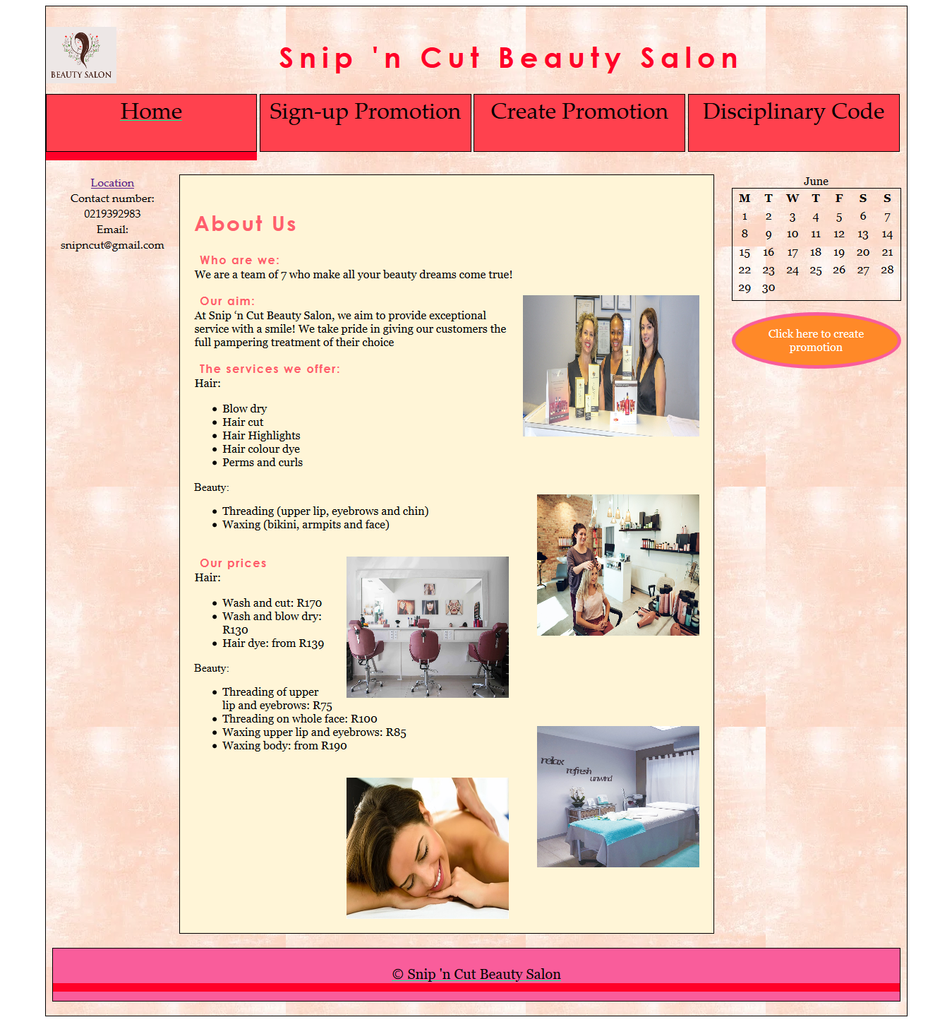

## Sign-up Page

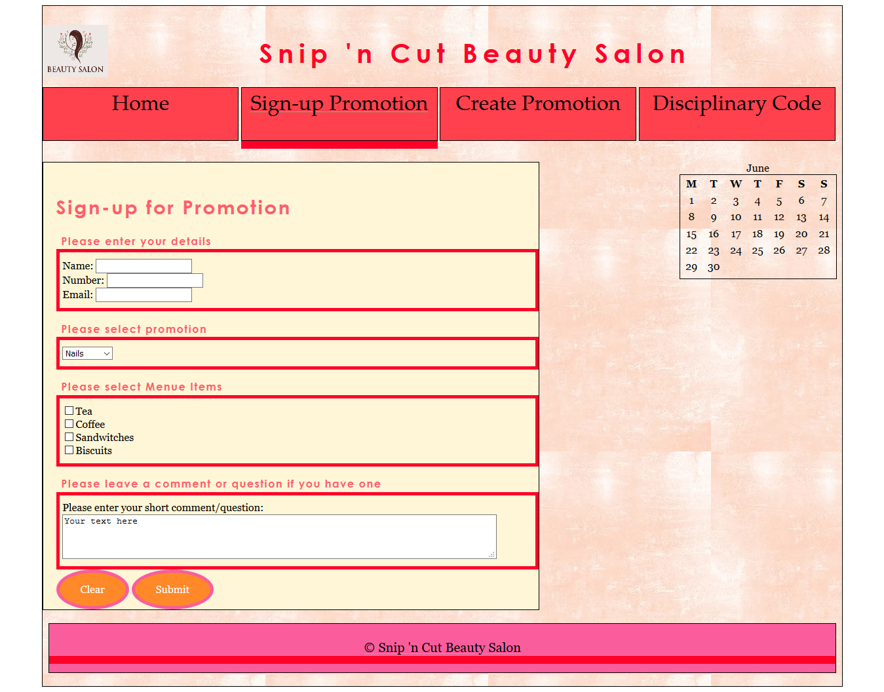

## Create Promotion Page

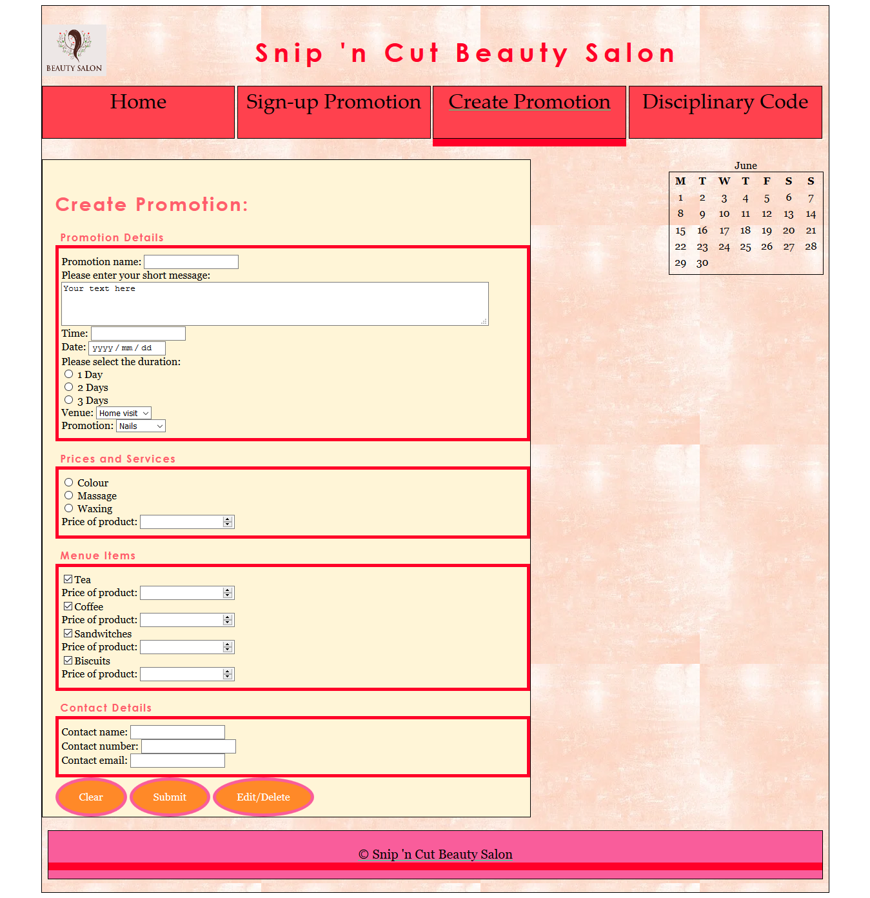

## Disciplinary Page

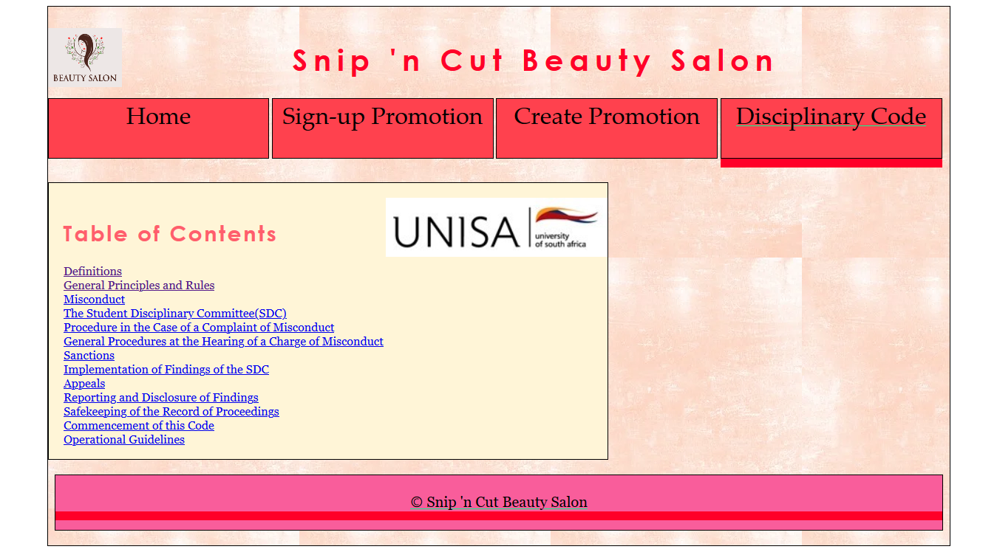

## Page 1

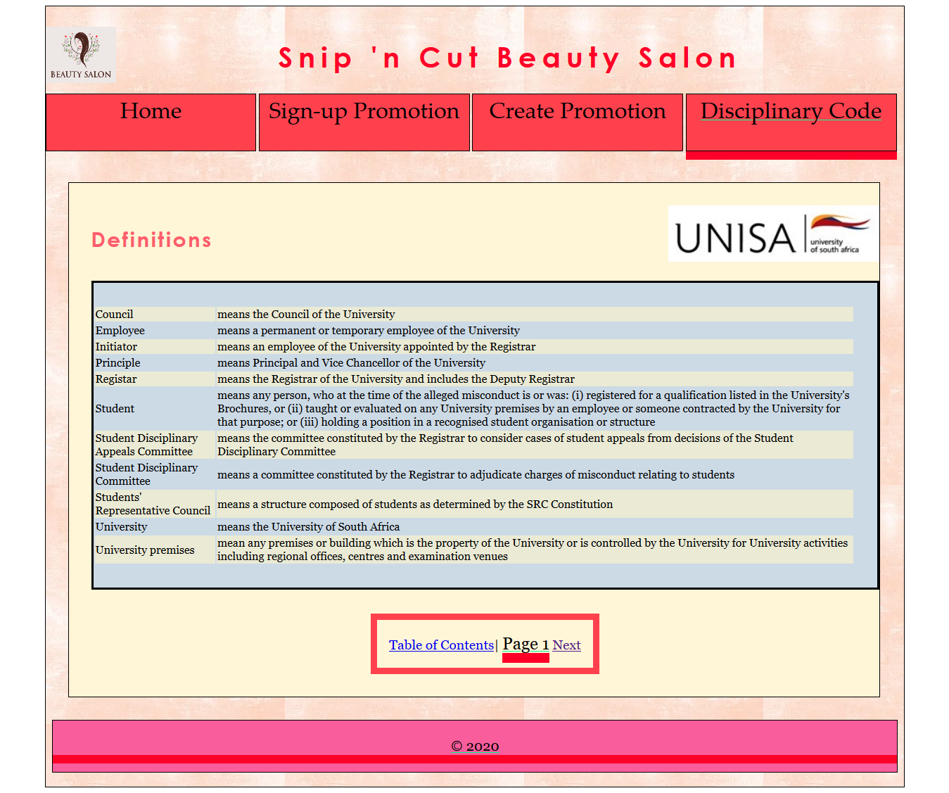

## Page 9

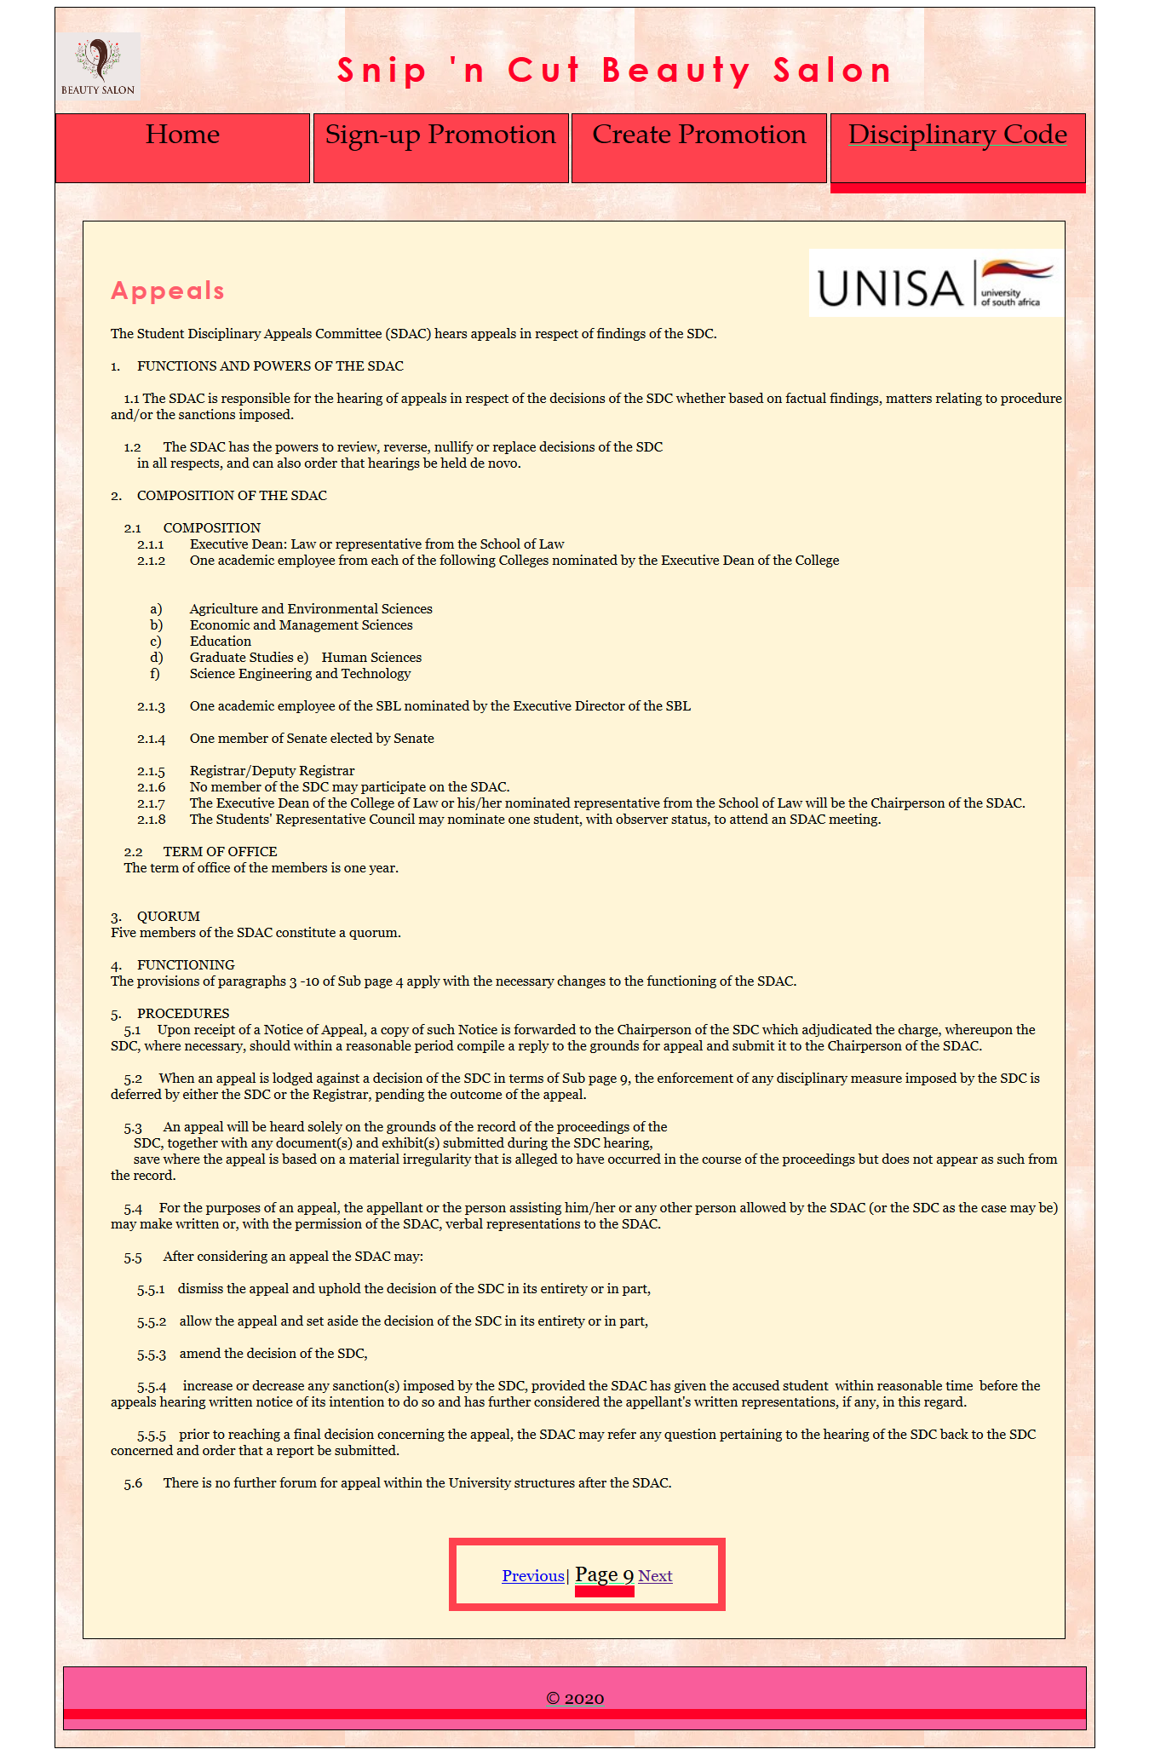

# Questions

# Rubric – Examination Project – ICT1513 100 marks

|  |  |  |  |  |
| --- | --- | --- | --- | --- |
| **Requirement** | **Mark allocation** | **Assignment 4 Mark** | **Student Mark** | **Marker Mark** |
| Was formatting requirements adhered to | 0 = None of the prescribed formatting was applied  5 = Some of the prescribed formatting was applied  6 = Template was implemented but not updated  8 = Template was implemented correctly  10 = Professional formatting applied | 10 | 10 |  |
| Case project website was created | 0 = Web site does not conform to project specifications at all  1 = Very limited conformation to project specifications  2 = Limited conformation to project specifications  4 = Exact conformation to project specifications  5 = Additional development done from project specifications | 5 | 5 |  |
| **Project Proposal**   * Site Title – Working title for the site must be specified * Developer – Student name and number * Need – Describe the need the web site will satisfy * Rationale or focus – Explanation of the content and goal of the site is given * Main elements outline – The main features of the site is described * Content – An estimate of the number of pages of the website is given * Target audience – A description is given of the audience that will be using the site * Design considerations – At least 3 elements are listed that will be considered when designing the site * Limiting factors – At least 3 technical or audience factors that could limit the design goals of the site is listed * Development schedule, milestones, and deliverables – using your study schedule as a basis, build a development schedule that indicates milestones and deliverables. * Mission statement * Tool used to determine site’s success in meeting its goals * Tool used to determine user satisfaction * Indicate technological issues that may influence site's development or function * Permission Letter | 0 = No project proposal included  3 = Very limited information included in project proposal  5 = Limited information included in project proposal  8 = All project proposal information required included  10 = Additional project proposal information included | 10 | 10 |  |
| Flow Chart   * Graphical representation of site structure * Connectivity of pages clearly indicated * Explanation as to why specific structure was selected * File name convention correct | 0 = No flowchart included  1 = Very limited conformation to flowchart requirements  2 = Limited conformation to flowchart requirements  4 = Exact conformation to flowchart requirements  5 = Additional information provided regarding flowchart | 5 | 5 |  |
| Wireframes and graphical representations of the page layouts   * 6 images required * Main components such as headings, navigation cues, link sets, text areas, etc. included | 0 = No images included  2 = Images to not correspond with final page layouts  4 = 6 Wireframes images included with limited use of headings, navigation cues, link sets, text areas, etc.  6 = 6 Wireframes images included clearly shows use of headings, navigation cues, link sets, text areas, etc. | 4/5 | 6 |  |
| HTML Pages   * Implementation of CSS * Pages correctly linked * Images correctly used * Lists incorporated * Good use of white space * General look and feel of the site * HTML pages conforms to Site Structure * HTML pages conforms to information in Project Proposal | 0 = No HTML code included  7 = Limited HTML code for less than 17 pages included  9 = Limited HTML code for 17 pages included  11 = HTML code not incorporating all requirements for less 17 pages included  13 = HTML code incorporating all requirements for less than 17 pages included  15 = HTML code not incorporating all requirements for 17 pages included  17 = HTML code incorporating all requirements for 17 pages included | 10/10 | 17 |  |
| Cascading Style Sheet   * Class and id selectors and elements * Font properties * Bulleted or numbered lists * Box models * Margin properties * Padding properties * Border properties * Page layout box properties * Flexible page layout * Image elements * Image properties * Color properties * Background images * Text-based navigation elements * Horizontal navigation bars * Vertical navigation bars * Hover rollovers | 0 = No CSS used  6 = Internal CSS used – limited elements implemented  8 = Internal CSS used – all elements implemented  10 = More than 1 CSS page with all elements implemented  12 = Limited use of required CSS elements in single CSS  14 = Exact use of CSS elements  16 = Extensive use of CSS elements | 8/8 | 16 |  |
| Screen dumps  6 images required | 0 = No images included  1 = Images do not conform to code  2 = Less than 6 images of rendered code  4 = 6 unclear images of rendered code in relation to code  6 = 6 clear images of rendered code in relation to code | 5/5 | 6 |  |
| Question 1 | 10 | N/A | 10 |  |
| Question 2 | 4 | N/A | 4 |  |
| Question 3 | 11 | N/A | 11 |  |